ECEN 325

Lab 3: Operational Amplifiers - Part 1

Section 506

02/11/2020

Jason Gilman

TA: Mandela

**Introduction:**

In this lab, we were tasked with studying the fundamental properties of operational amplifiers. We constructed and tested various configurations including inverting, non-inverting, and voltage follower operational amplifiers.

**Calculations:**

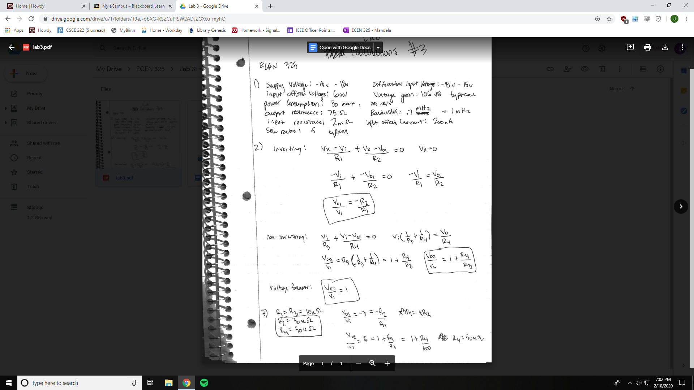

**Schematics:**

Inverting op-amp

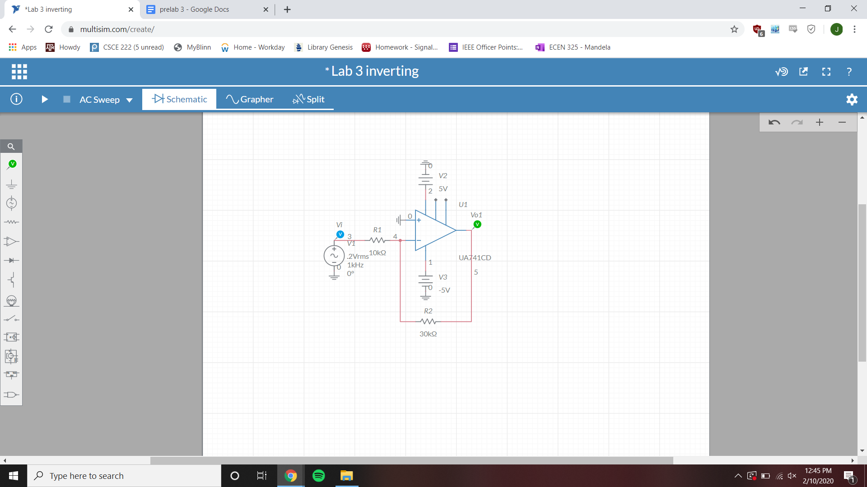

Non-Inverting op-amp

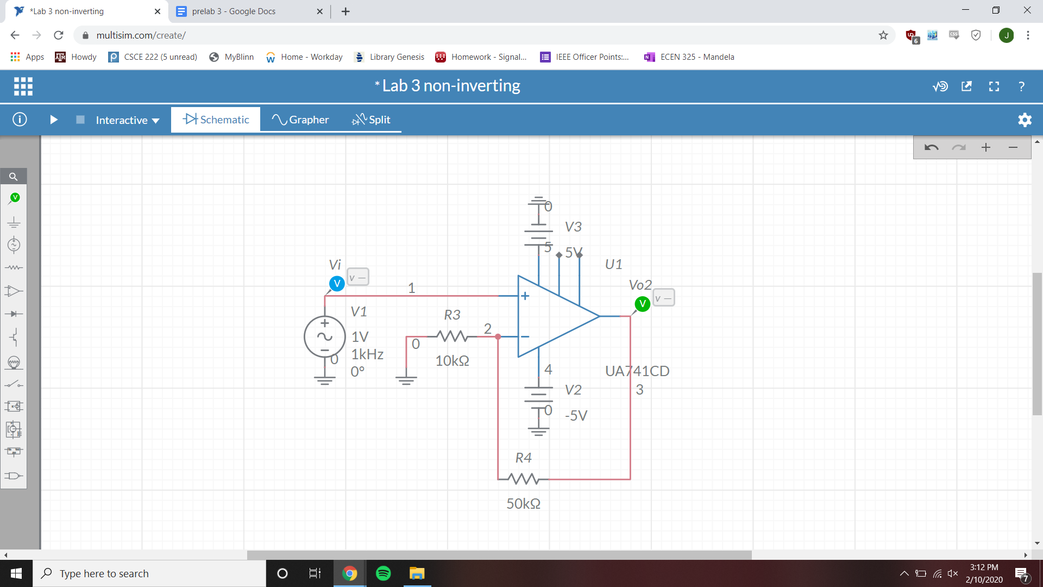

Voltage Follower op-amp

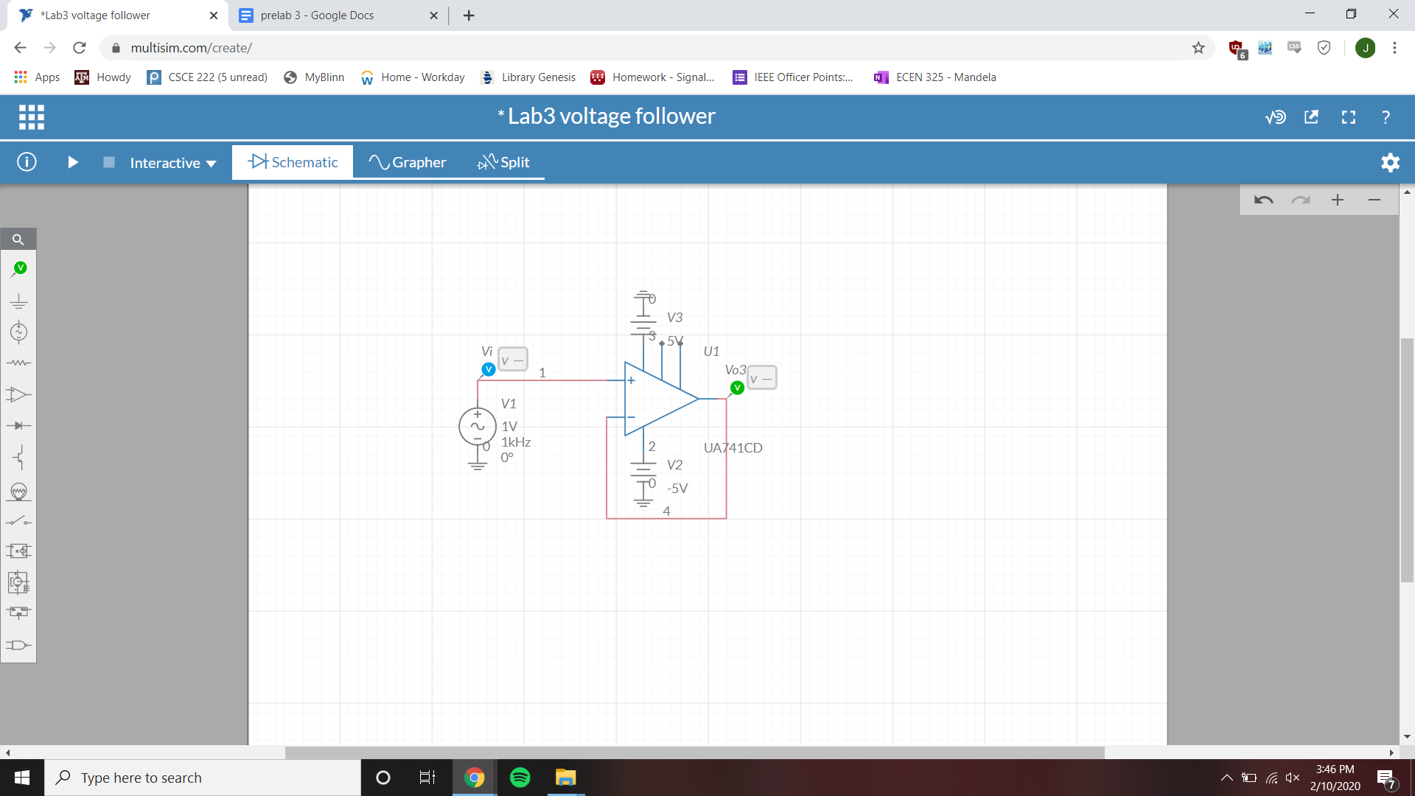

**Simulations:**

Inverting op-amp bode simulation

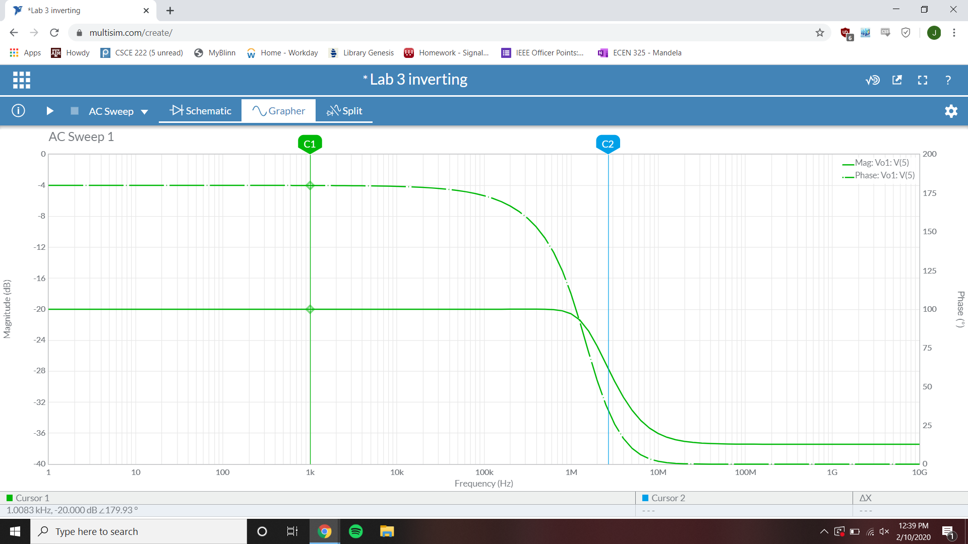

1k Hz gain = -20 dB

Inverting op-amp time-domain simulation

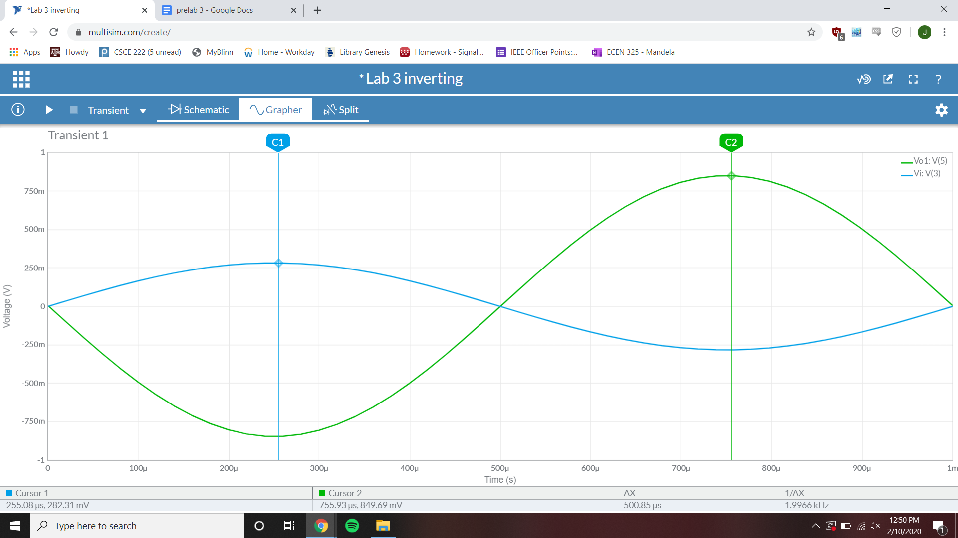

Gain = 3.009 mV/mV

Inverting op-amp parameter-sweep simulation

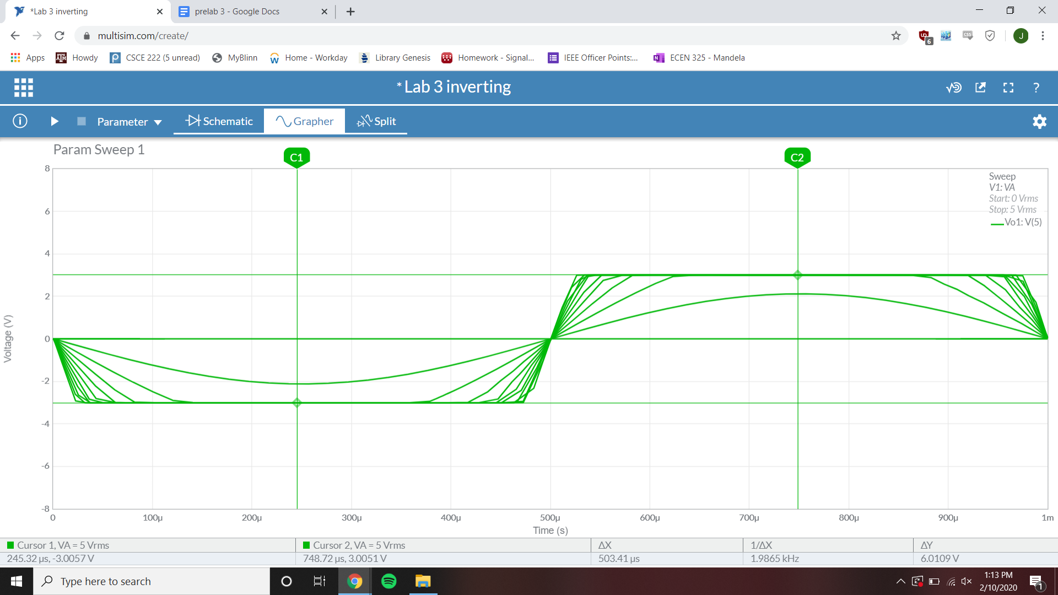

Clipping point Vi = ~1 V

Inverting op-amp fourier simulation

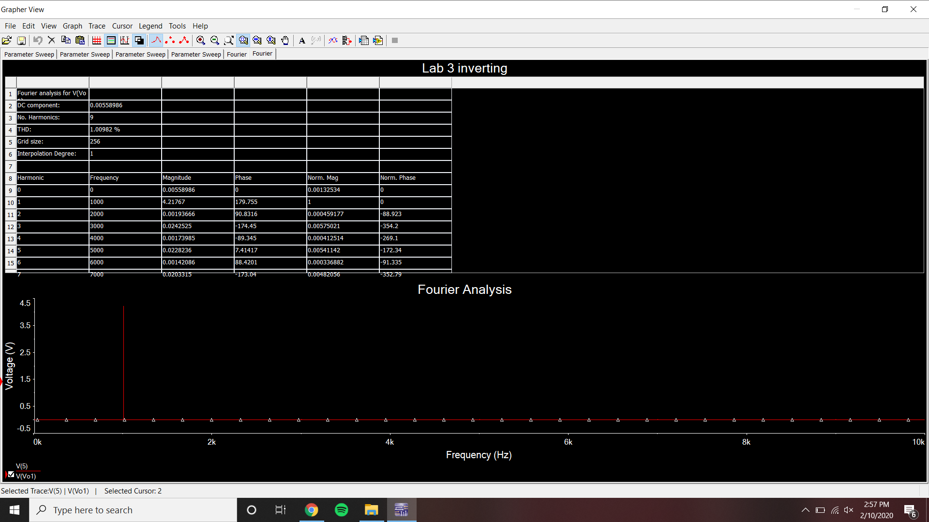

THD = 1.00982%

Non-Inverting op-amp bode simulation

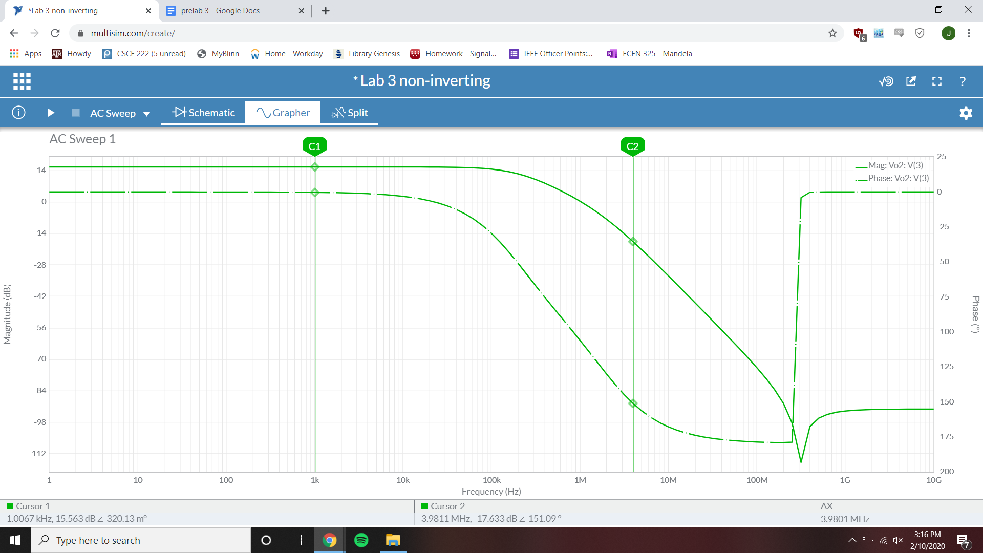

1 kHz gain = 15.563 dB

Non-Inverting op-amp time-domain simulation

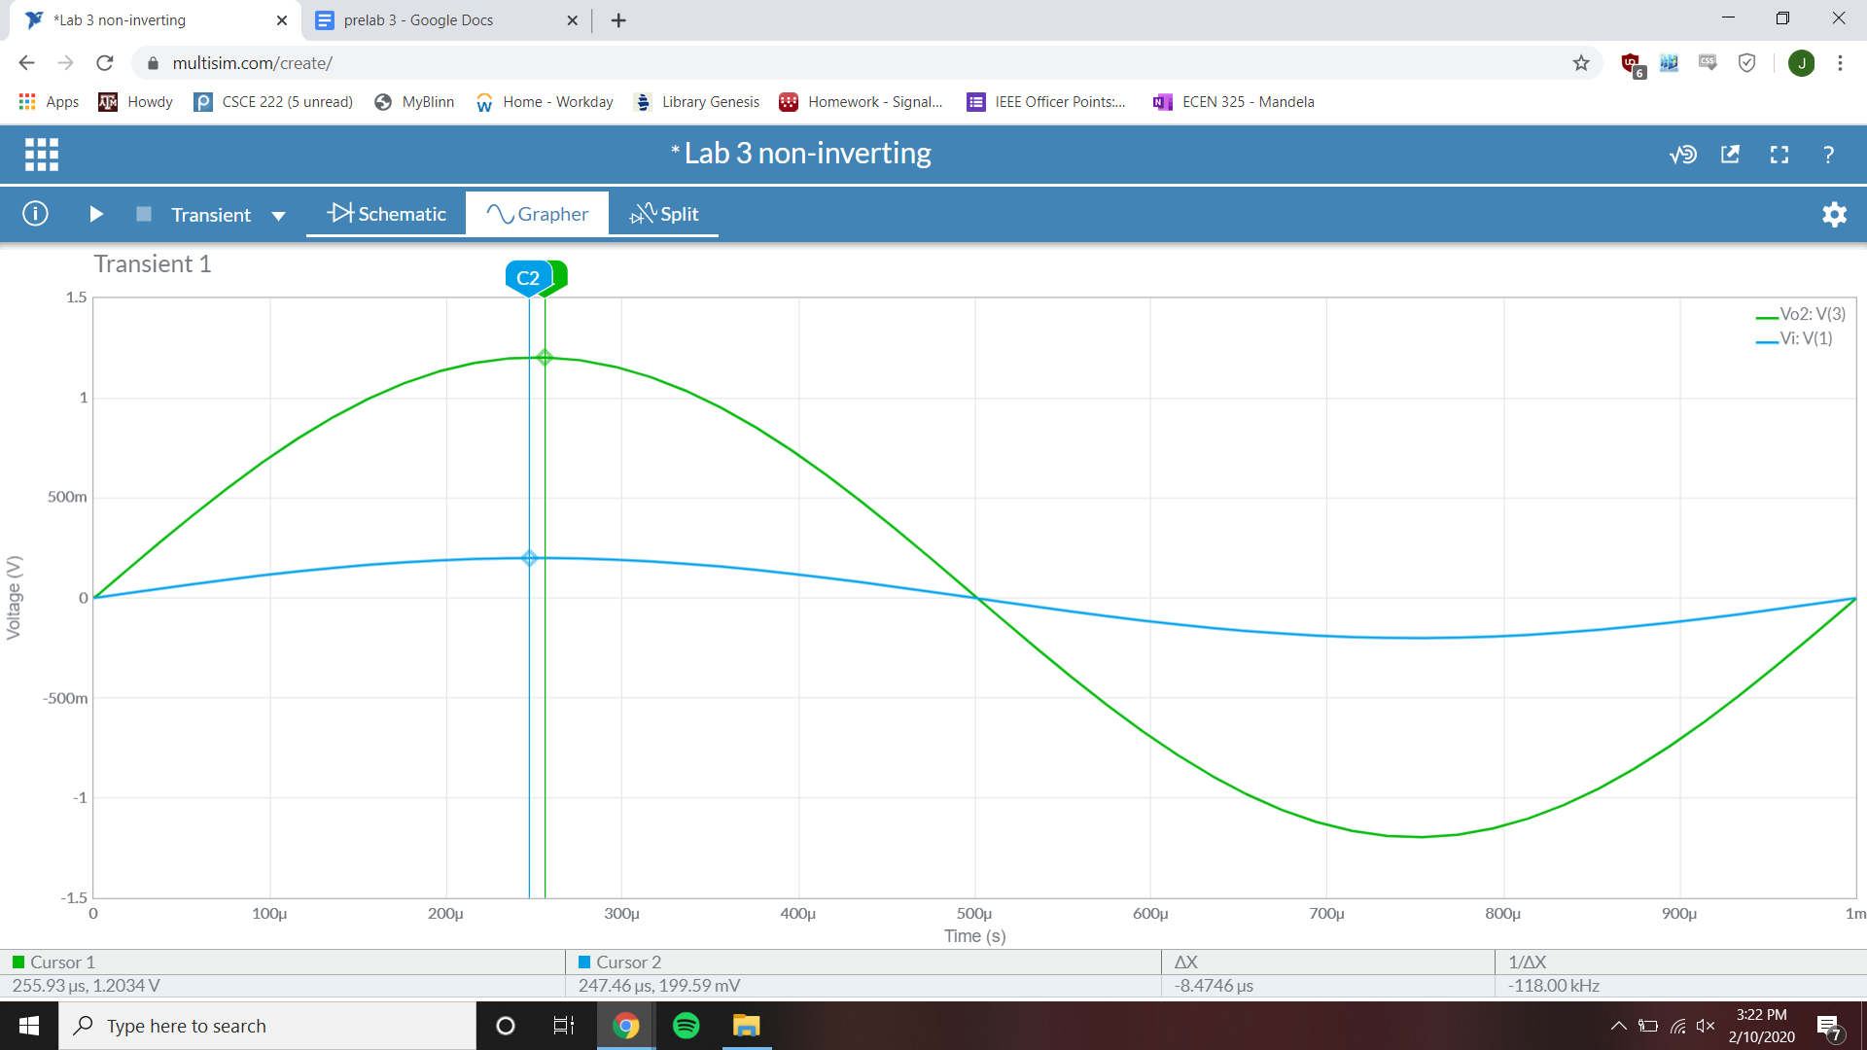

Gain = 6.029 V/V

Non-Inverting op-amp parameter-sweep simulation

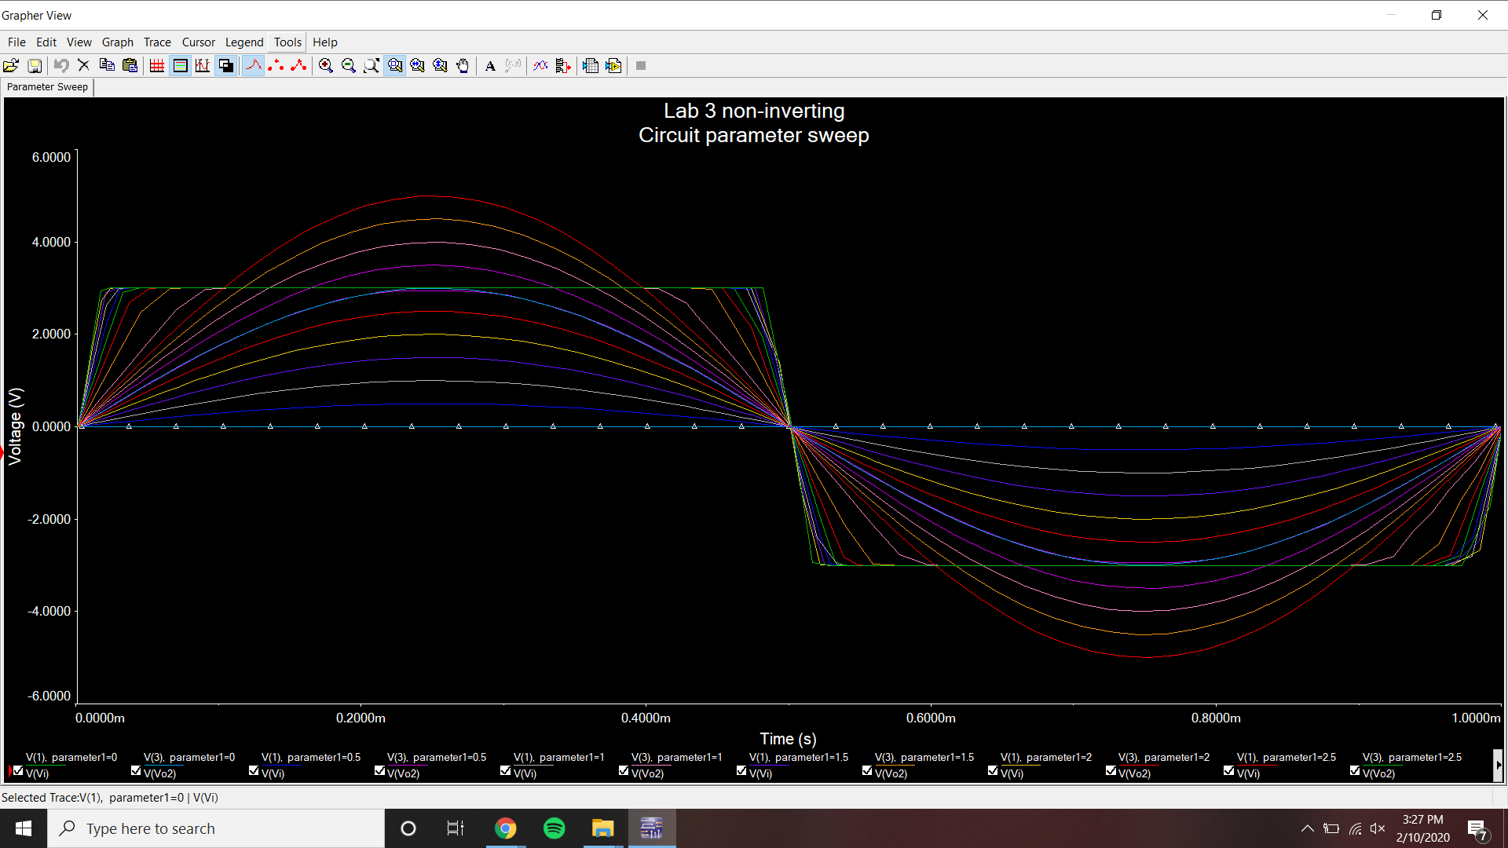

Clipping point Vi = ~1 V

Non-Inverting op-amp fourier simulation

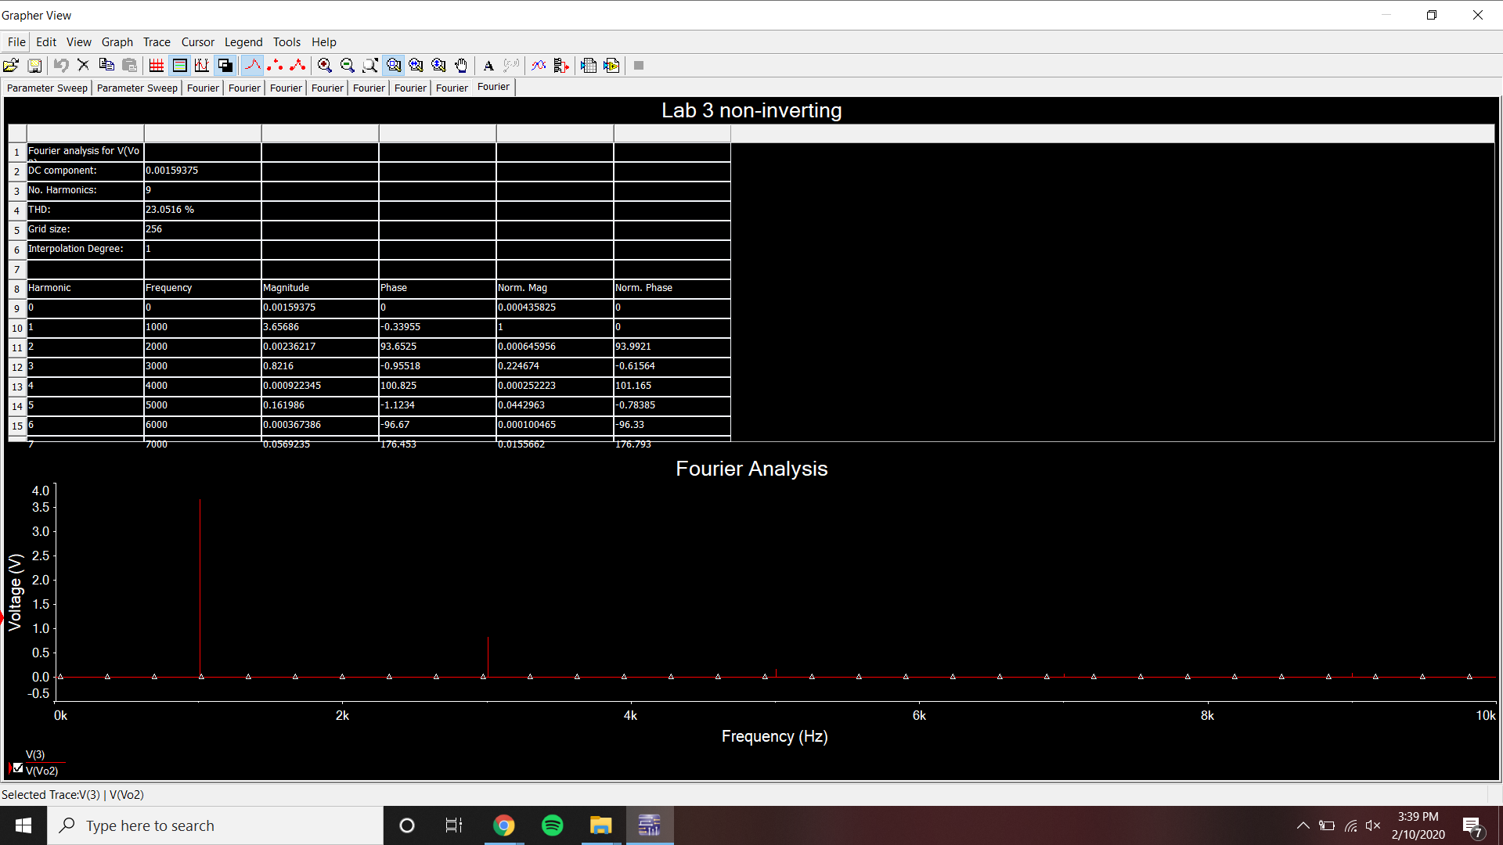

THD = 23.0516%

Voltage Follower op-amp bode plot

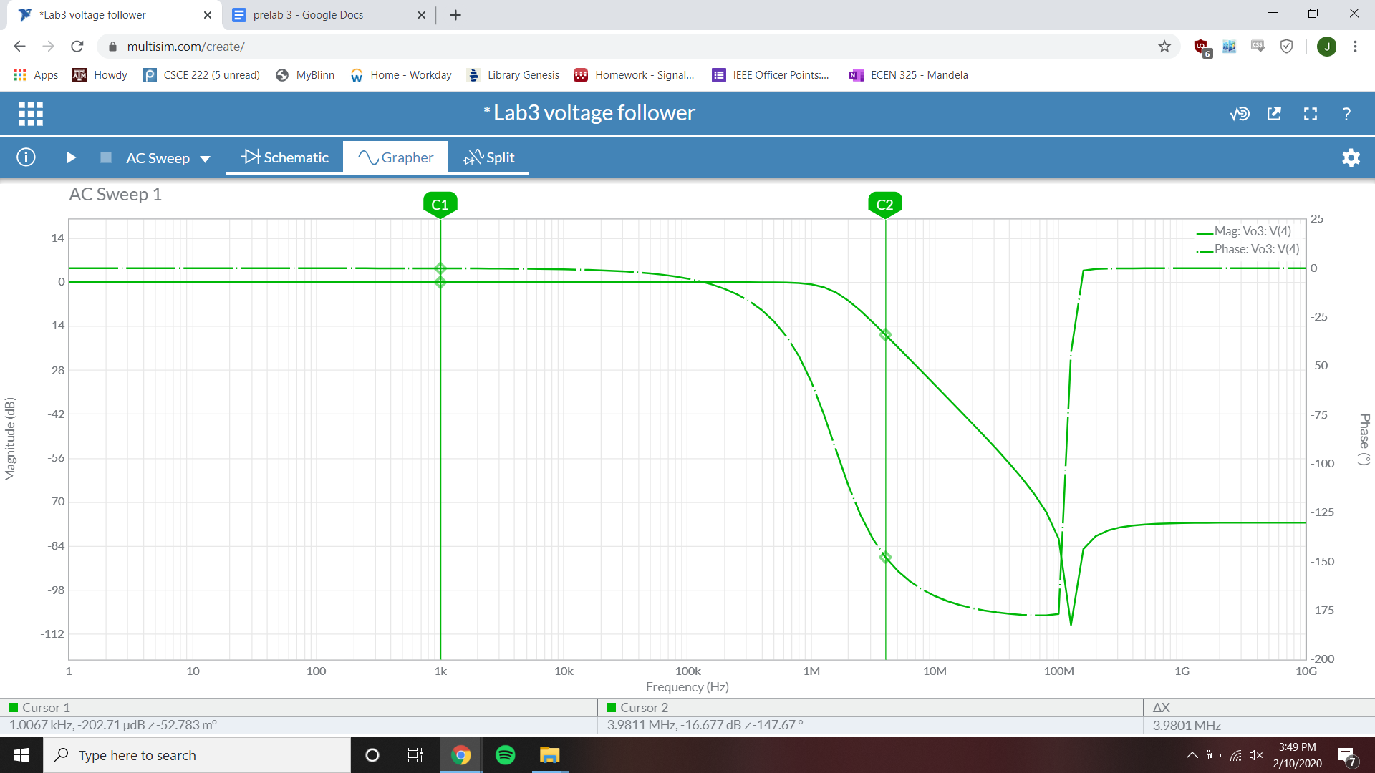

1 kHz gain = -202.71 µdB

Voltage Follower op-amp time-domain simulation

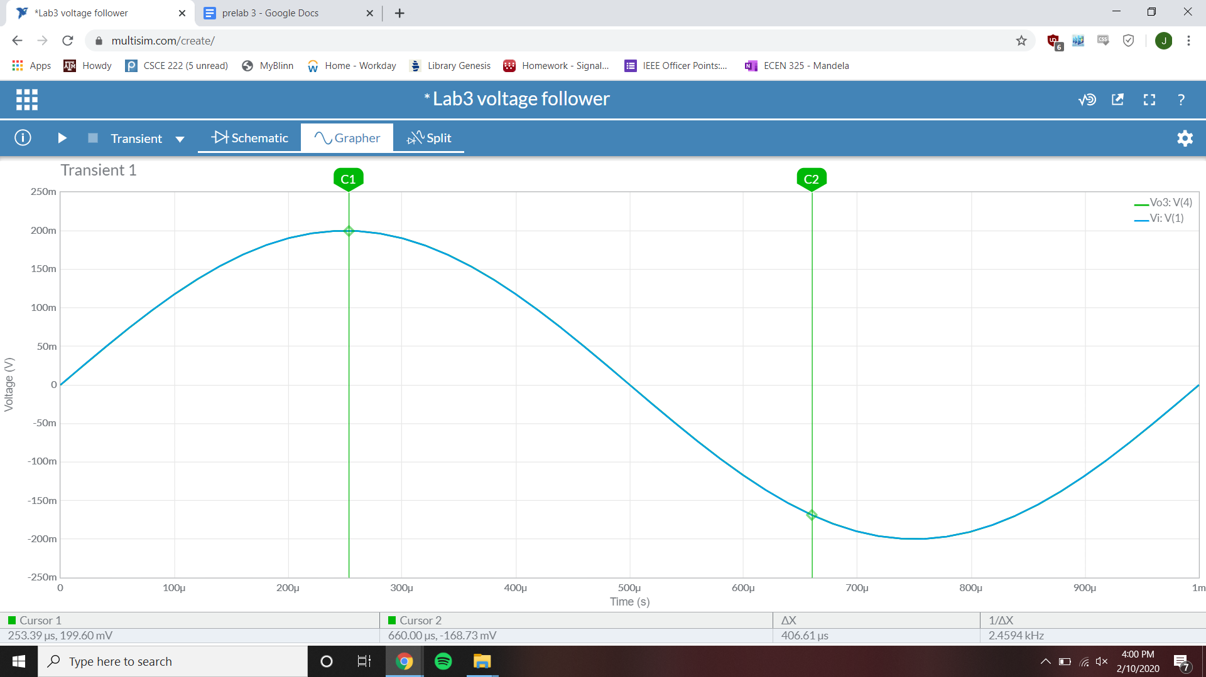

Gain = 1 V/V

Voltage Follower op-amp parameter-sweep simulation

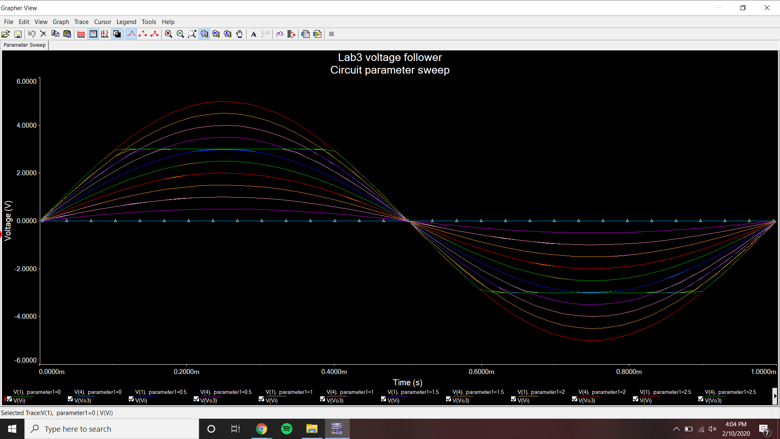

Clipping point Vi = ~3 V

Voltage Follower op-amp fourier simulation

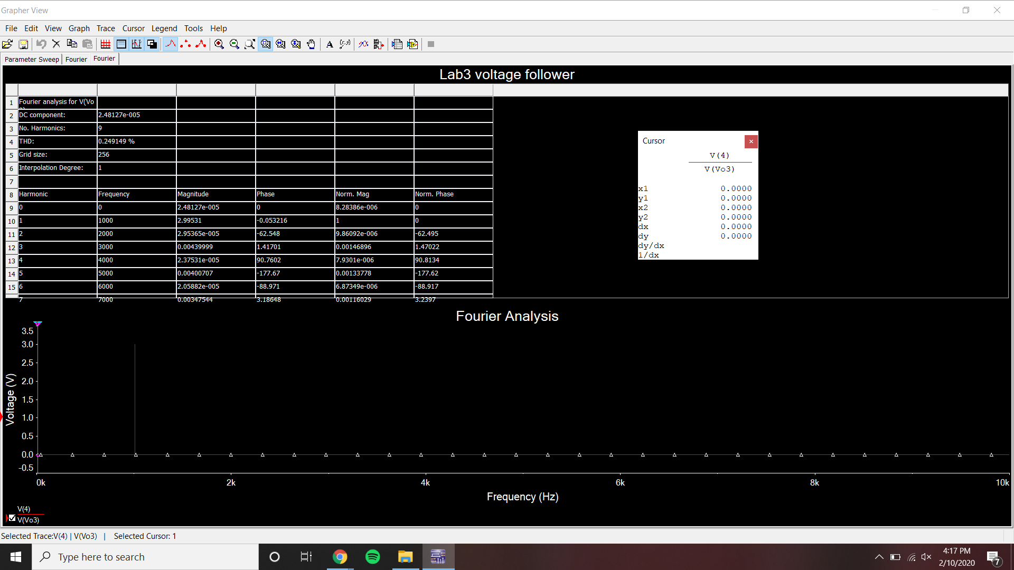

THD = .249129%

**Measurements:**

Input offset current measurement

Voltage across 100k Ohm resistor on negative terminal

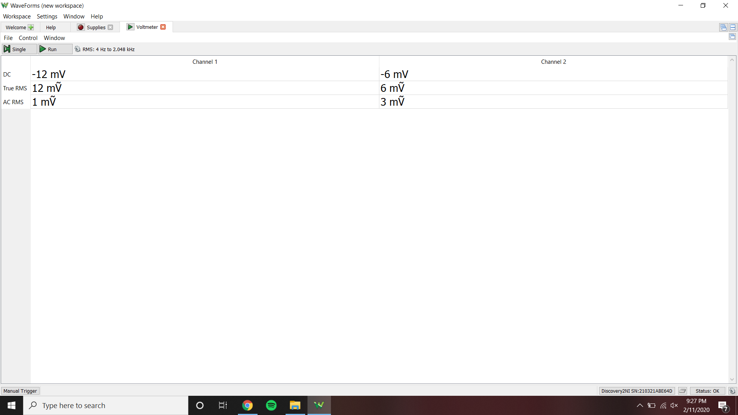

Voltage across 100k Ohm resistor on positive terminal

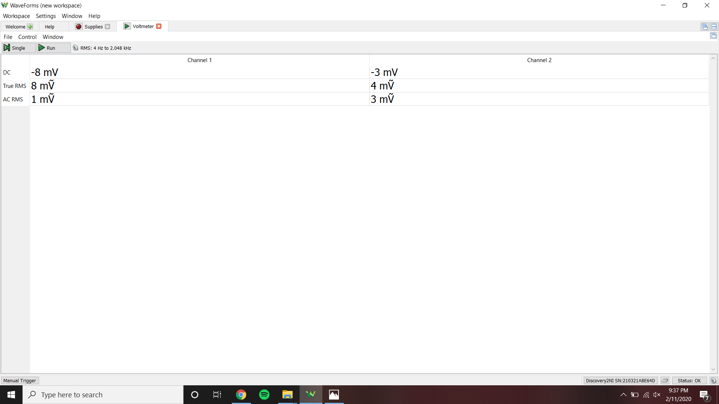

Input Offset Current = -40 nA

DC Offset Voltage Measurement

Output Offset Voltage = 13 mV

Gain = 5.9 V/V

Input offset voltage = 2.203 mV

Offset voltage compensated by potentiometer

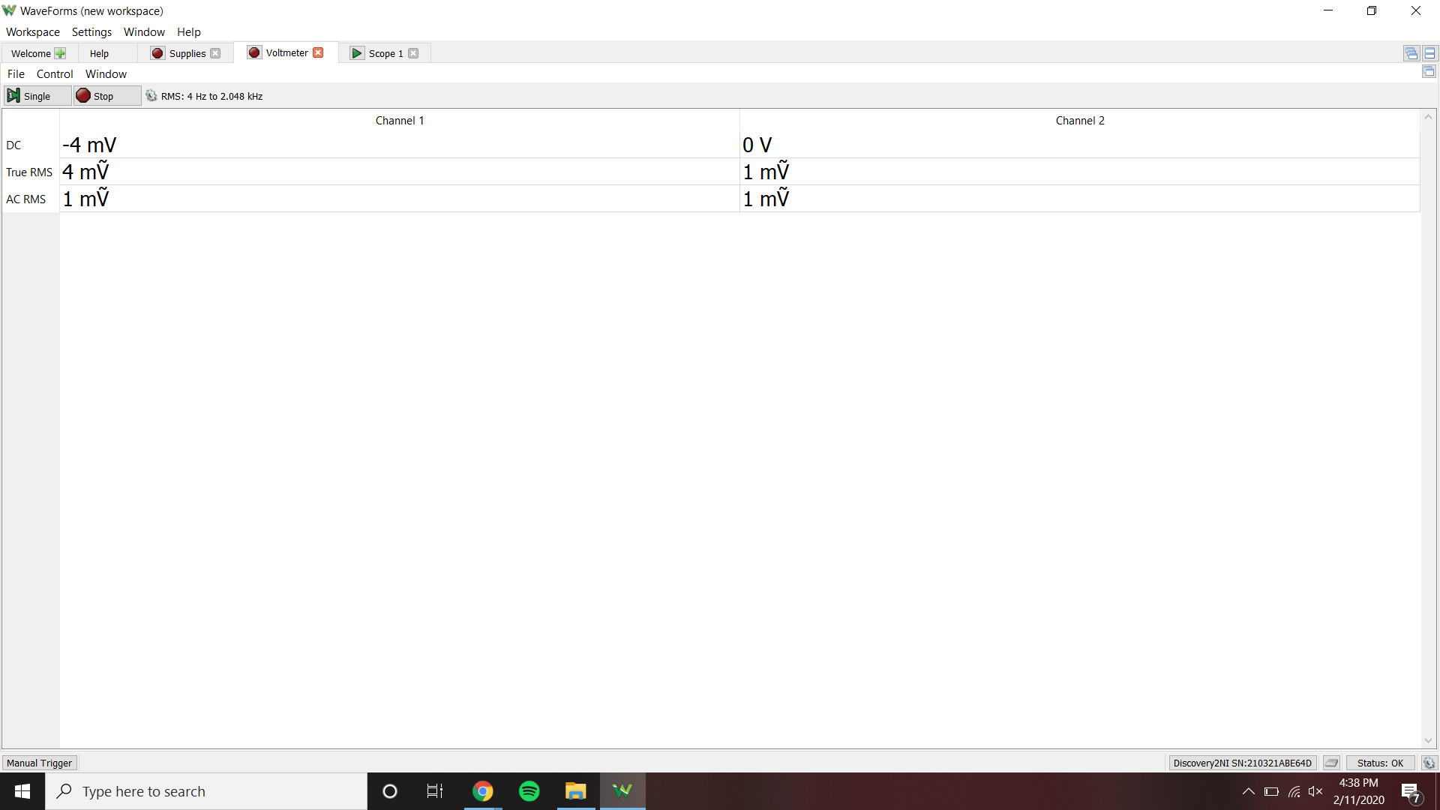

Inverting and Non-inverting Configurations

Inverting op-amp bode plot

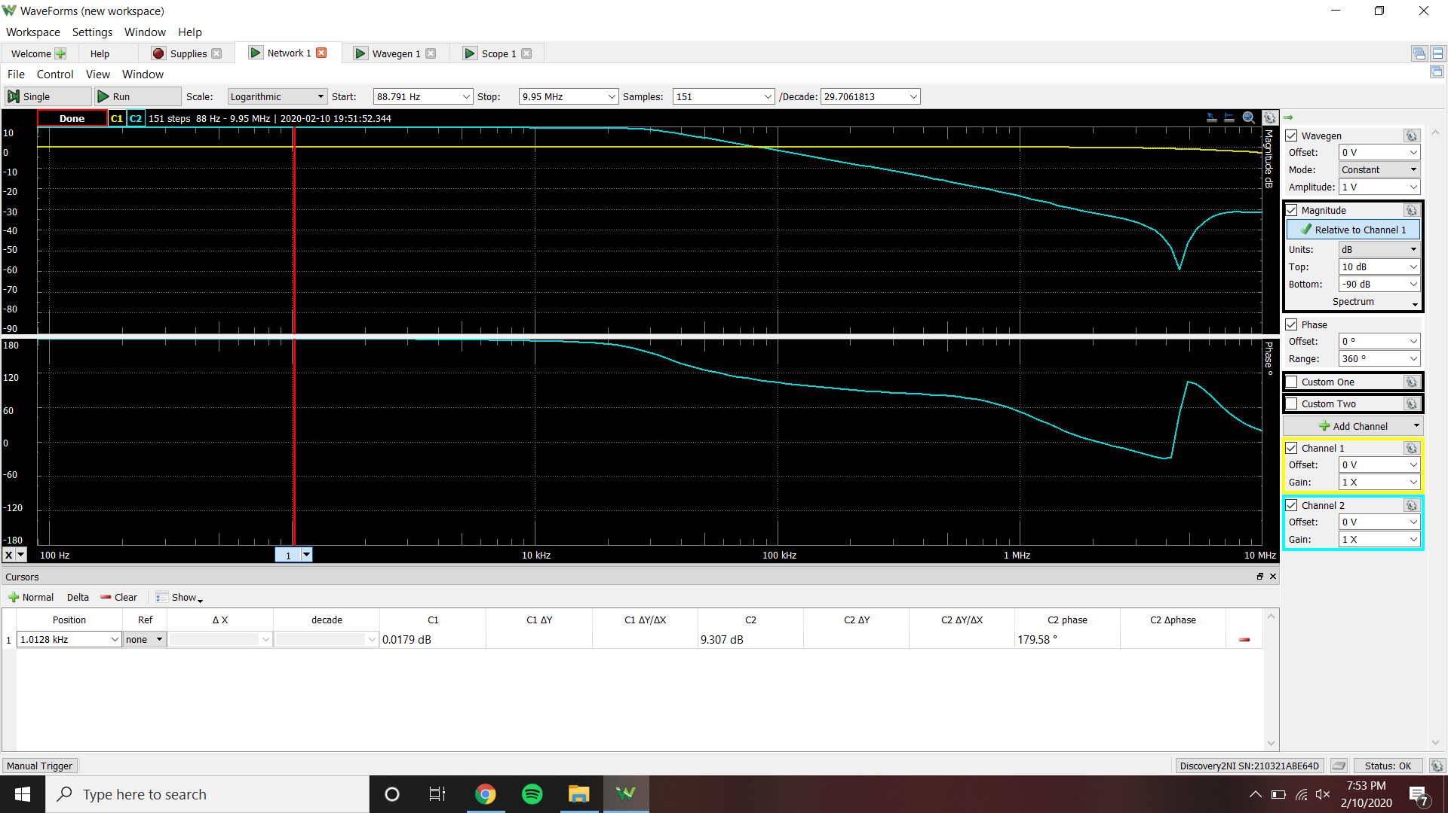

Gain at 1 kHz = 9.307 dB

Inverting op-amp time-domain plot

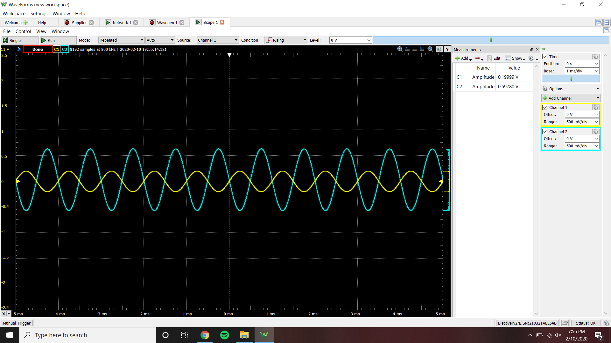

Gain = 2.98915 V/V

Inverting op-amp Vi,max

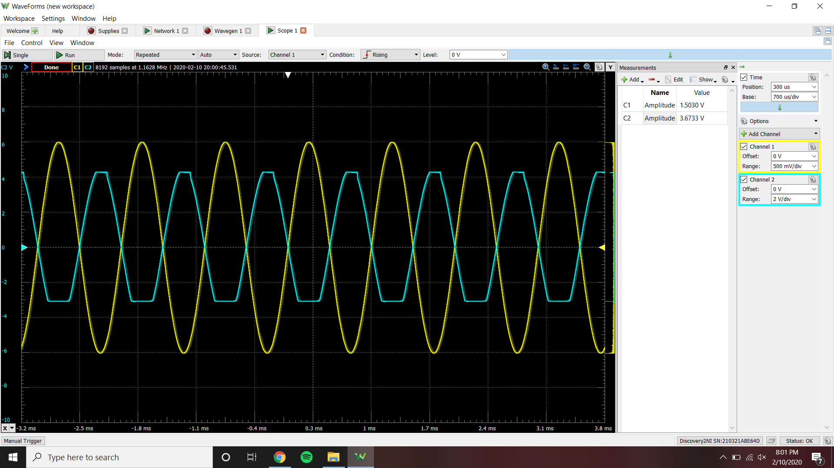

Vi,max = ~1.2 V

Inverting op-amp Spectrum plot

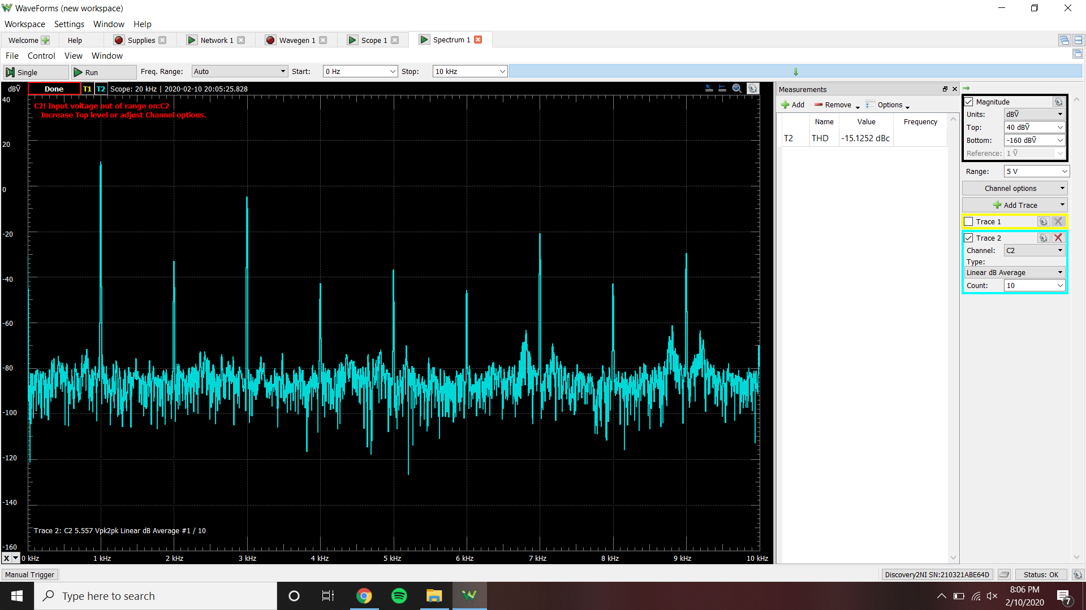

THD = 17.5283%

Non-Inverting op-amp bode plot

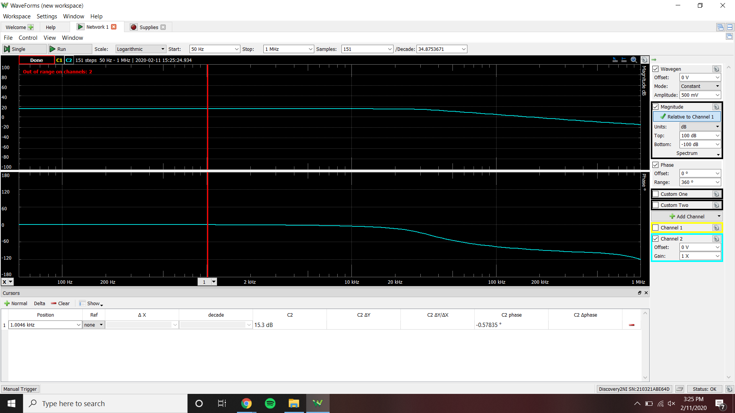

Gain at 1 kHz = 15.3 dB

Non-Inverting op-amp time-domain plot

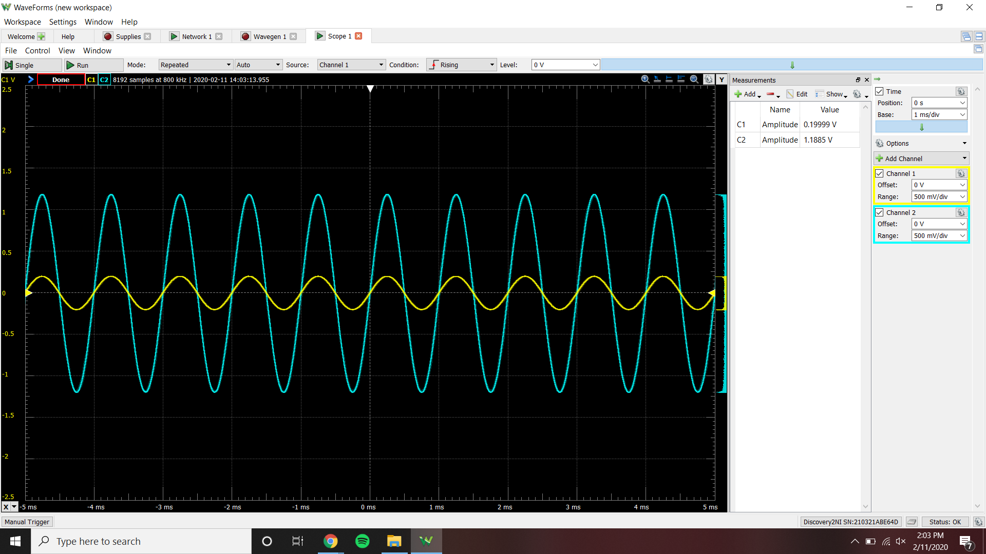

Gain = 5.94547 V/V

Non-Inverting op-amp Vi,max

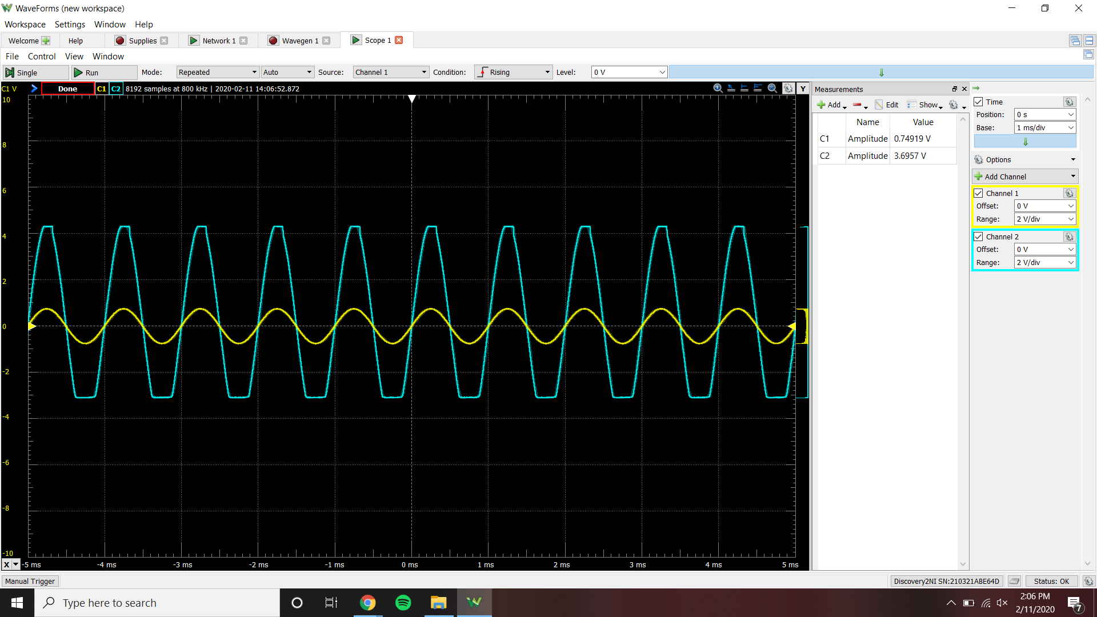

Vi,max = ~.75 V

Non-Inverting op-amp Spectrum plot

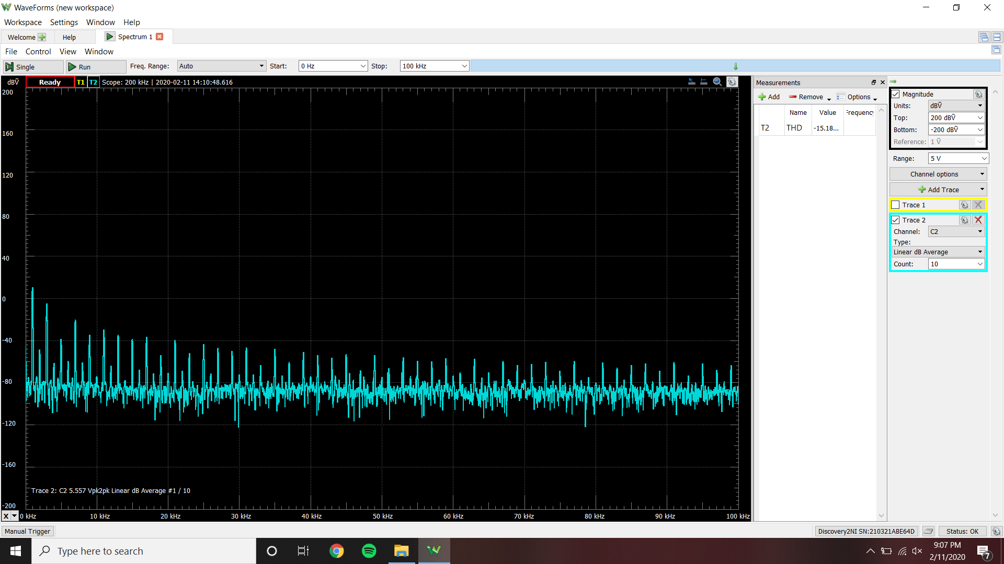

THD = 17.4182%

Voltage follower op-amp bode plot

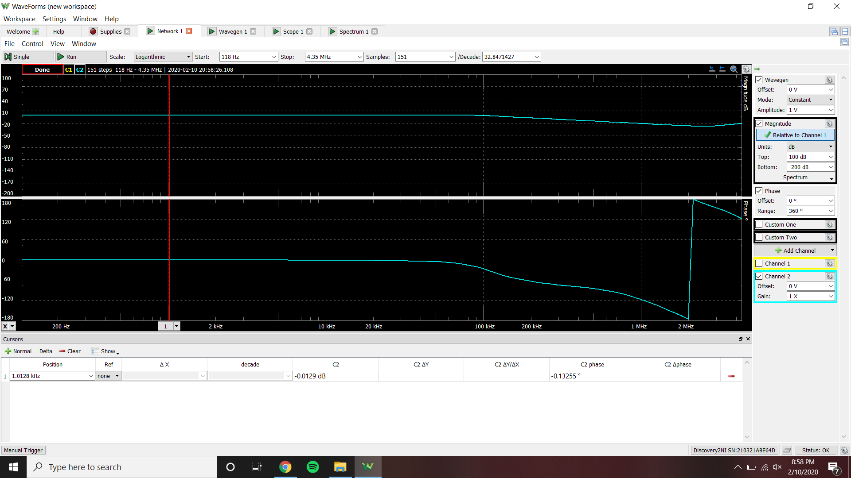

Gain at 1 kHz = -.0129 dB

Voltage follower op-amp time-domain plot

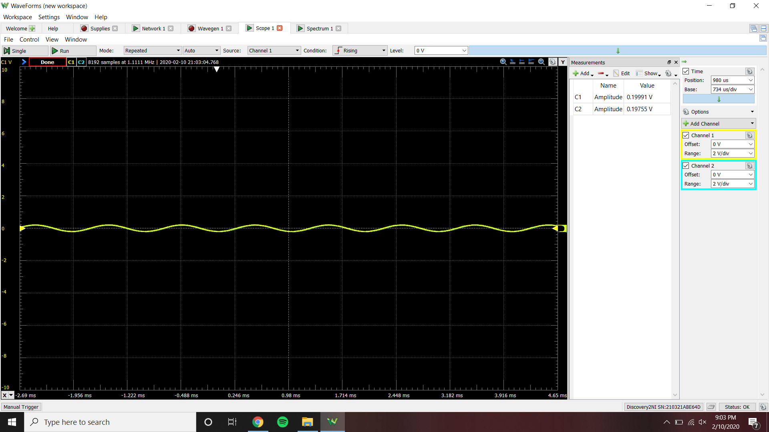

Gain = .987 V/V

Voltage follower op-amp Vi,max

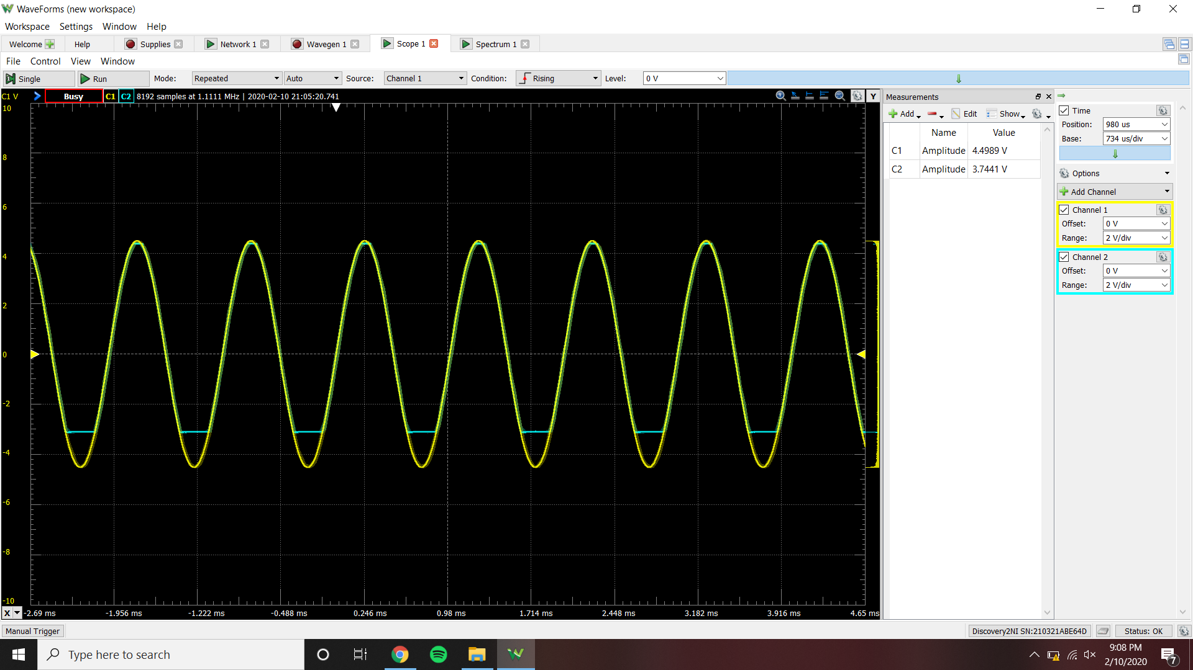

Vi,max = ~3.2 V

Voltage follower op-amp Spectrum plot

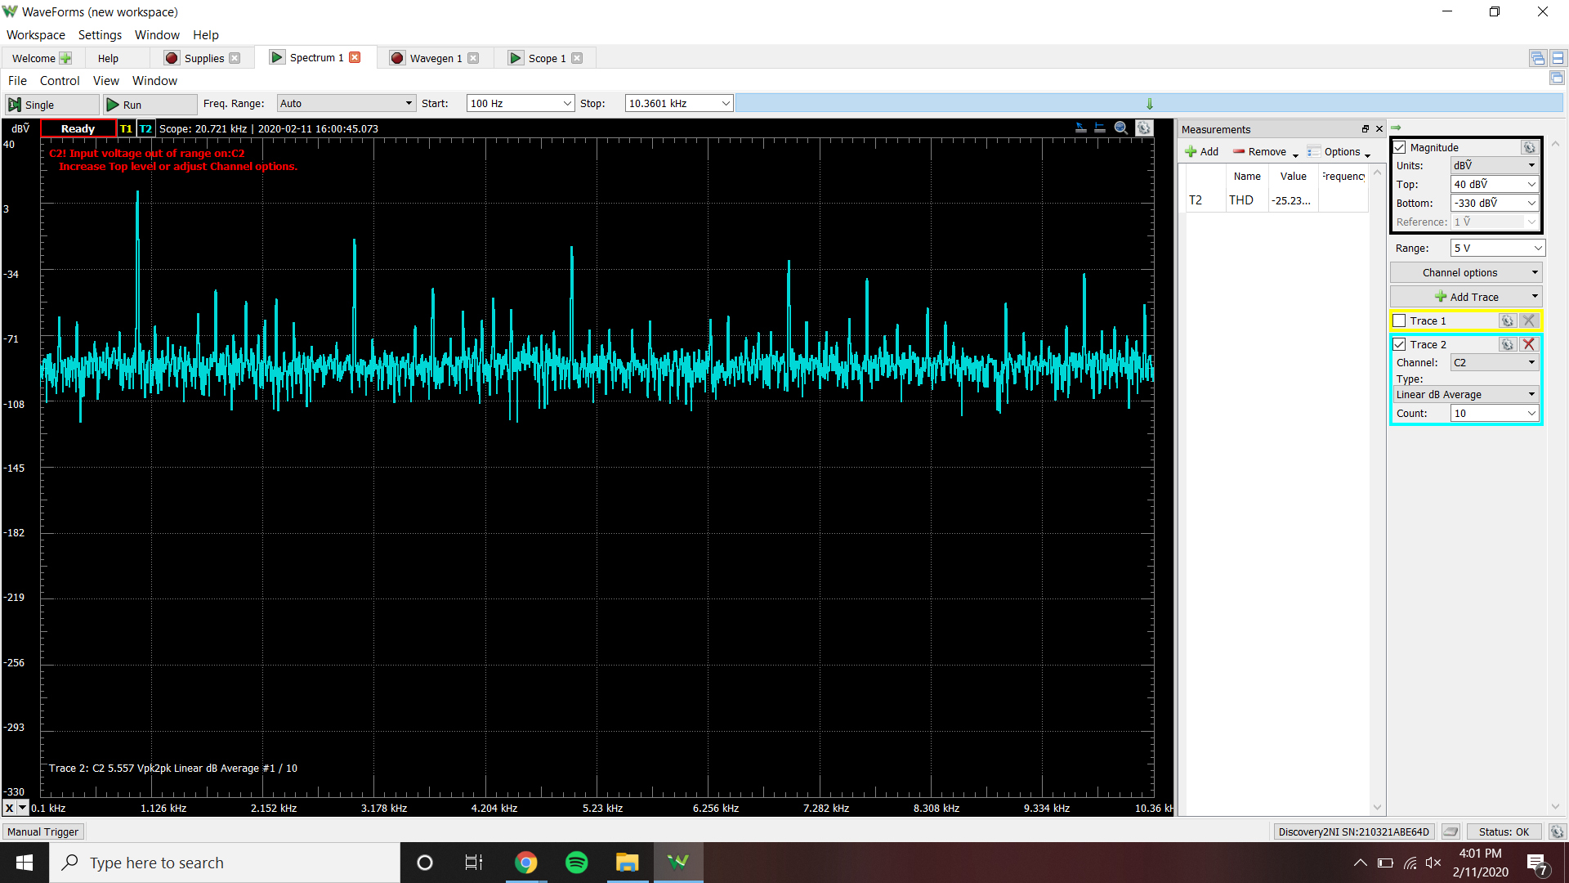

THD = 5.47646%

|  |  |  |
| --- | --- | --- |
|  | Measured | Data Sheet |
| Input Offset Current | -40 nA | 20 nA |
| Input Offset Voltage | 2.203 mV | 1 mV |
| Output Offset Voltage | 13 mV | 15 mV |
| Maximum Voltage Output | 4.3 V | 5 V |
| Minimum Voltage Output | -3.11 V | -5 V |

|  |  |  |
| --- | --- | --- |
|  | Simulated | Measured |
| Gain at 1 kHz, Inverting | -20 dB | 9.307 dB |
| Gain, Inverting | 3.009 V/V | 2.98915 V/V |
| Vi,max, Inverting | ~1 V | ~1.2 V |
| THD, Inverting | 1.00982% | 17.5283% |
| Gain at 1 kHz, Non-Inverting | 15.563 dB | 15.3 dB |
| Gain, Non-Inverting | 6.029 V/V | 5.94547 V/V |
| Vi,max, Non-Inverting | ~1 V | ~.75 V |
| THD, Non-Inverting | 23.0516% | 17.4182% |
| Gain at 1 kHz, Voltage-Follower | -202.71 µdB | -.0129 dB |
| Gain, Voltage-Follower | 1 V/V | .987 V/V |
| Vi,max, Voltage-Follower | ~3 V | ~3.2 V |
| THD, Voltage-Follower | .249129% | 5.47646% |

**Conclusion:**

Comparing the two sources of data, simulated and measured, you can see that most of the measured data is justified from the simulated circuits. The only outliers exist in the measure results of the total harmonic distortion. Although, since the values are still under a certain limit, they are acceptable results compared to the simulated results. Ideally, the 741 operational amplifier has output voltages of -5 to +5 Volts, although in reality, through measured results, the operational amplifier used in this lab only ranged from -3.11 to +4.3 Volts. This phenomenon could explain the differences in some of the measurements when comparing simulated and measured results.